**DEPLOY THE PYTHON BASED APPLICATION**

# SIGN into the AWS console and create an ec2 instance with the ubuntu server and give the customized vpc and security group are

SSH-22 HTTP-443 HTTPS-8080

TCP-7070,8000

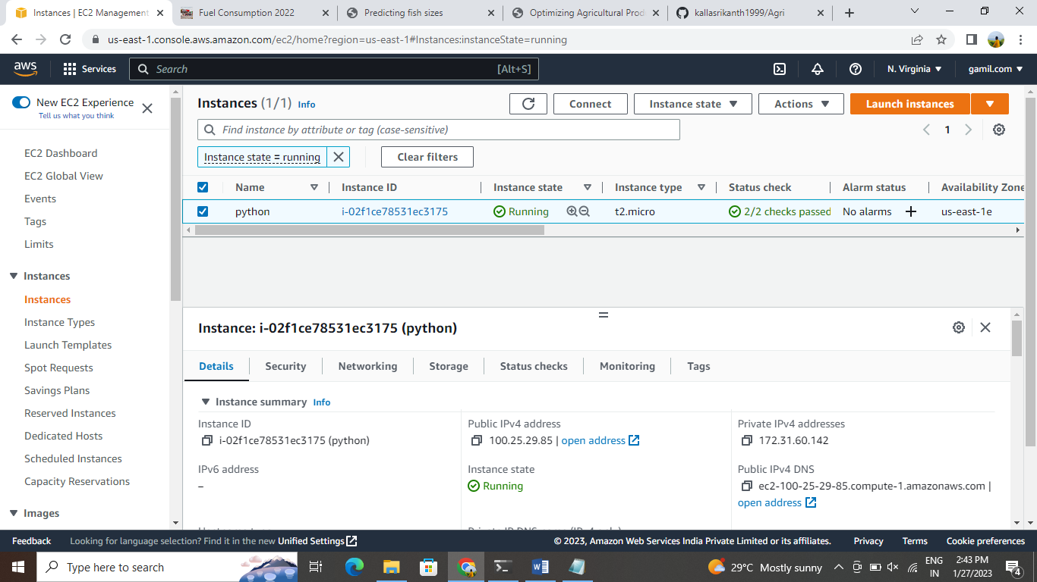

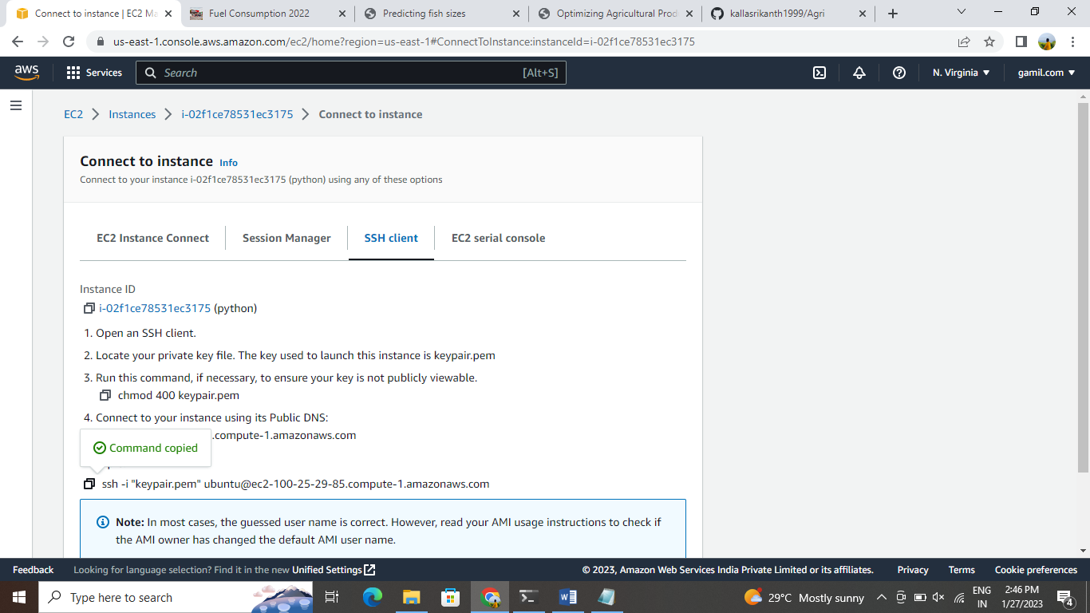

Connect the ec2 instance with the terminal and update the system with the help of the command

----> sudo apt update

After upgrade the packages in the ubuntu machine with the help of the command Sudo apt-get full-upgrade –y

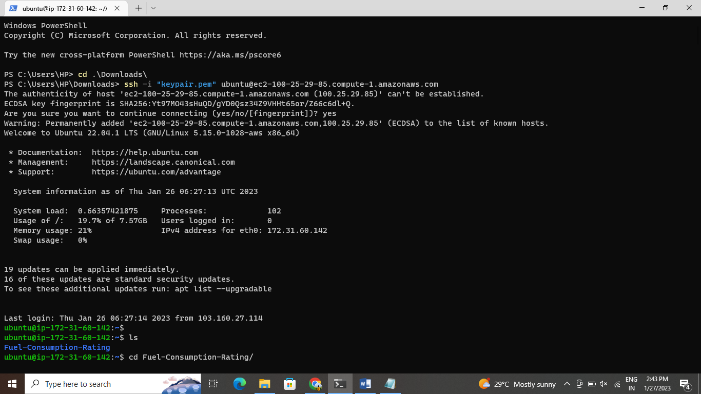

After upgrade the packages in the ubuntu machine with the help of the command Sudo apt-get full-upgrade –yAnd then install the python in the ubuntu machine

Pip3 is the official package manager and pip command for python3 .it enables the installation and management of third party software packages with features and functionality not found in the python standard library.

And clone the code from the repository by using

Git clone <https://github.com/TGourisankar/flight-prediction.git>

nd go to the directory install the required packages and run the flask server

--> pip3 install –r requirements.txt

--> python3 app.py

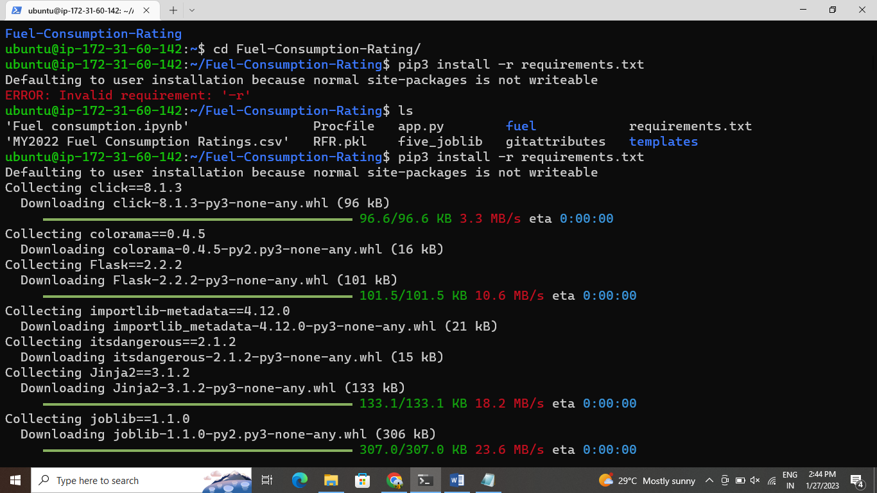

Here, after running python3 app.py it will generate local host ip address we can’t access web app with

that ip adress then here we want to edit the file app.py with some details.

Sudo vi app.py

Go to the very bottom of the file and paste the following text and save the file

App.run(host=’0.0.0.0’, port=8080, debug=True)

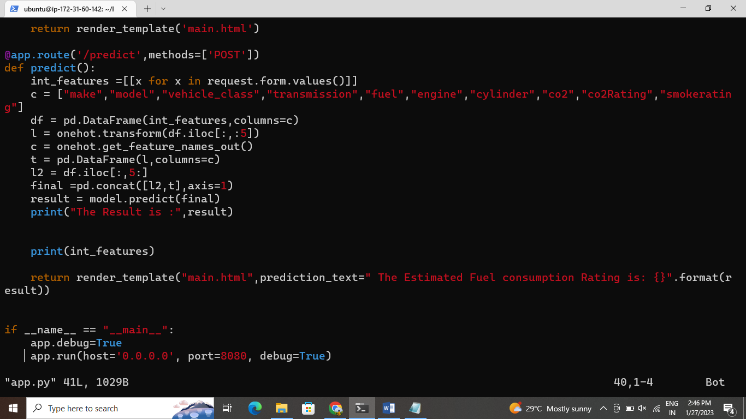

Now again run the flask server by using the below command Python3 app.py

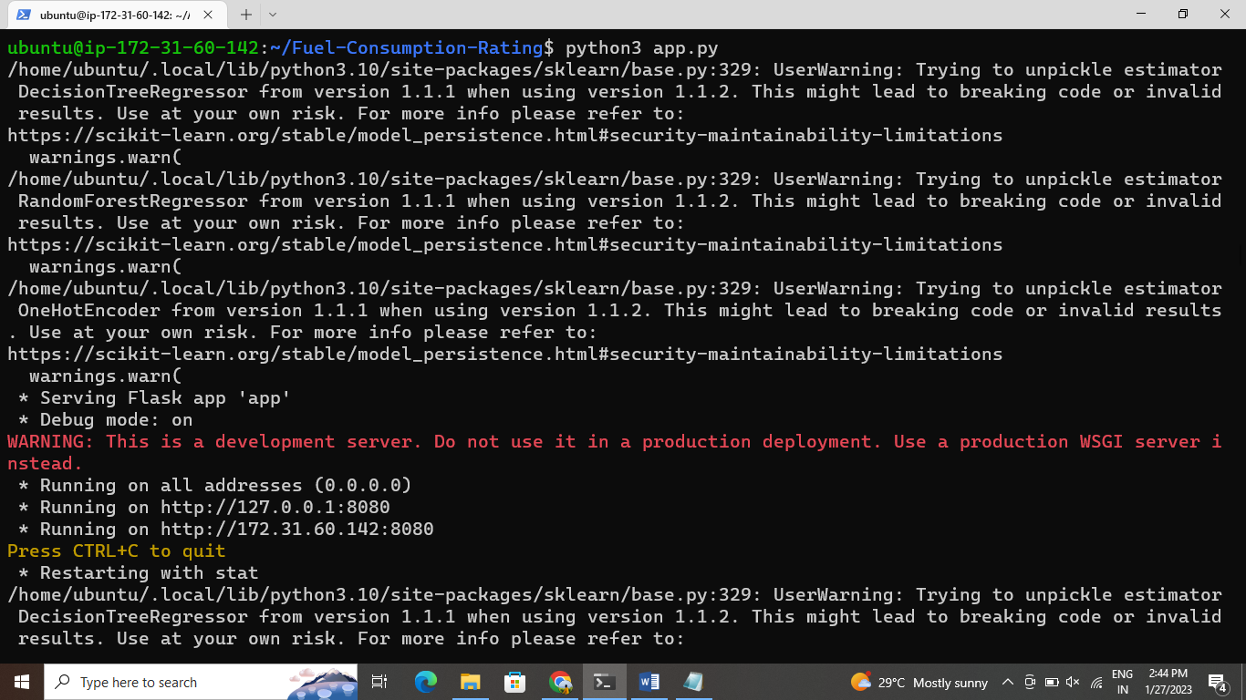

Copy the public ip adress and paste it on terminal with required port number

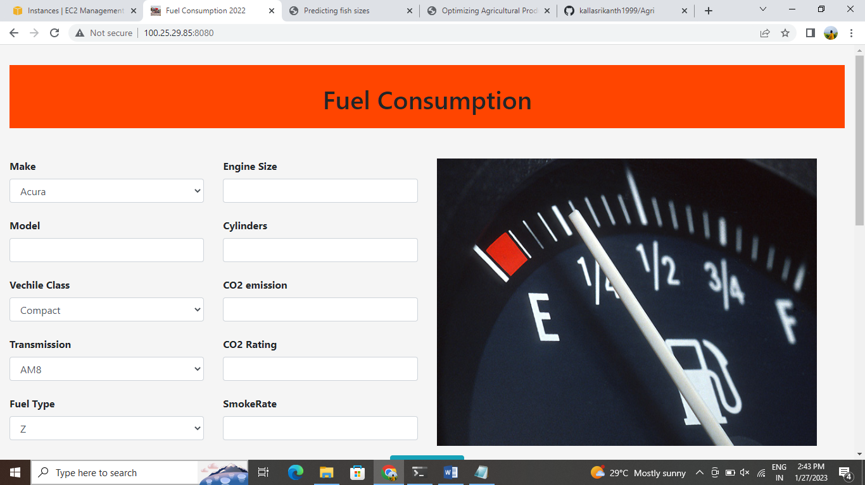

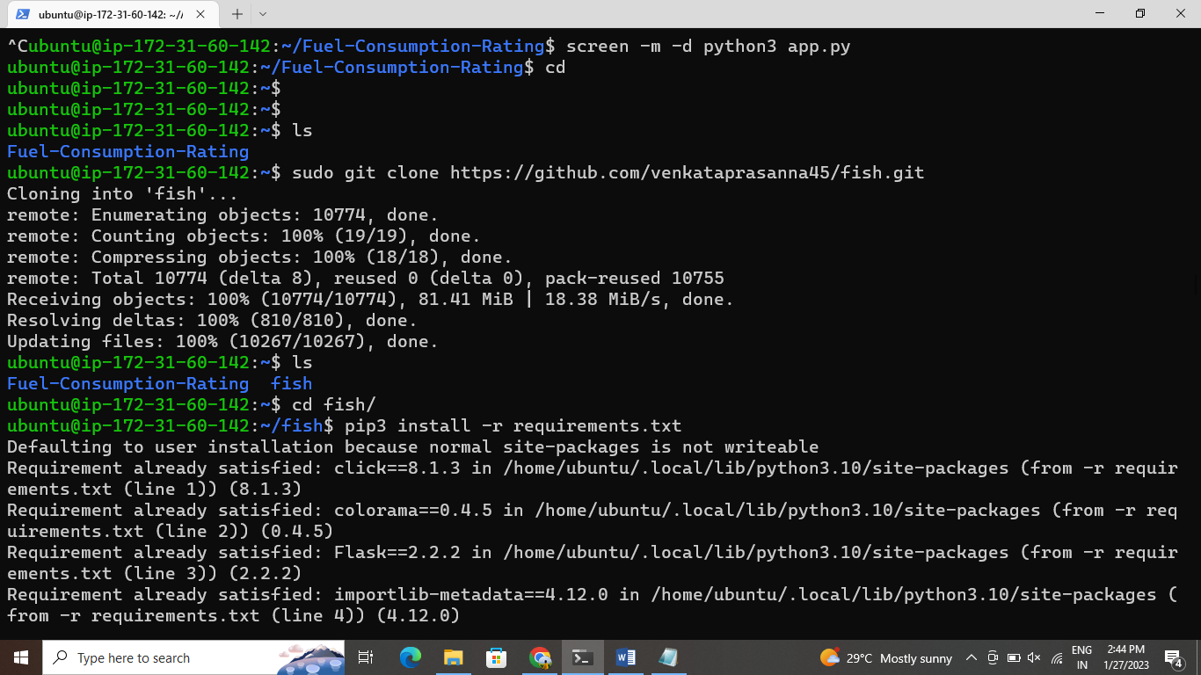

And again clone the fishrepository

Go to that directory install the requirements .txt Run the flask server

Edit the sudo vi app.py

And again run python3 app.py

Copy the public ip adress and paste it on the browser



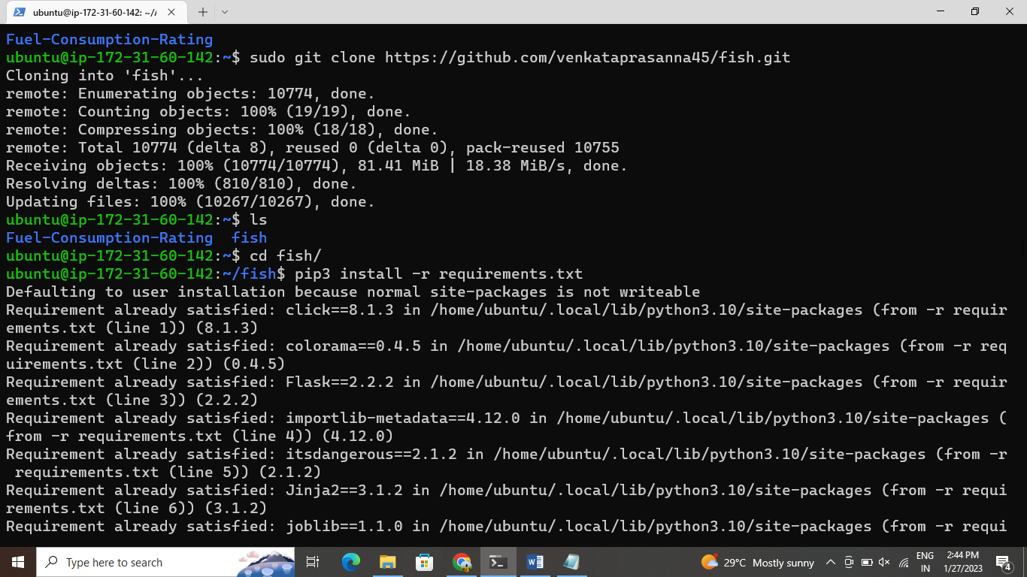

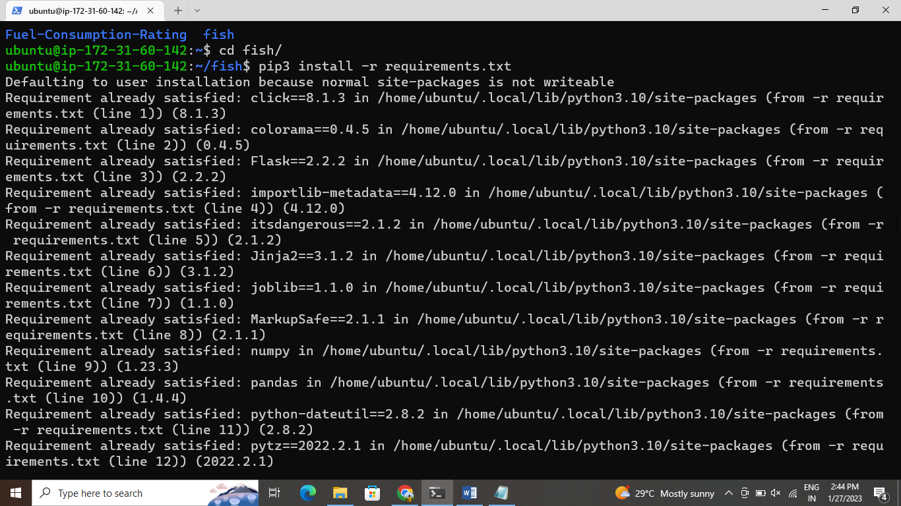

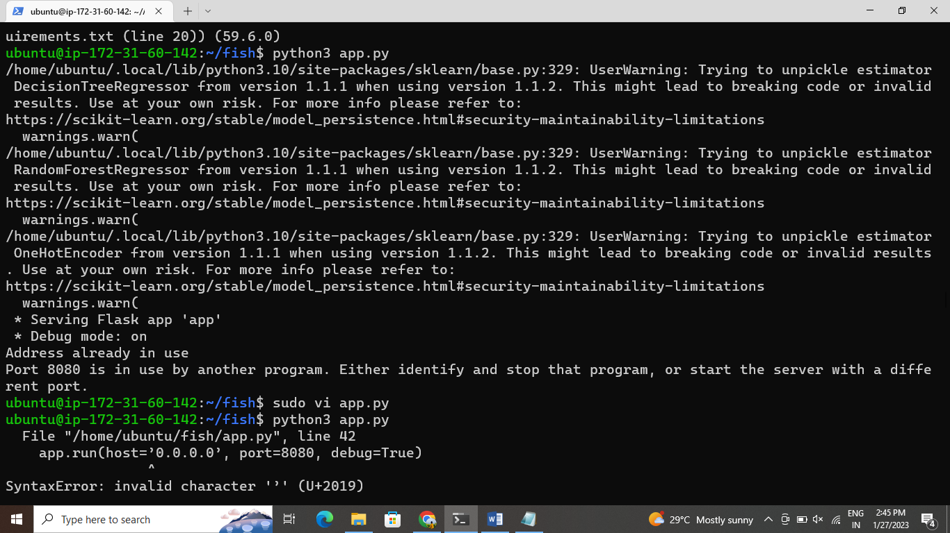

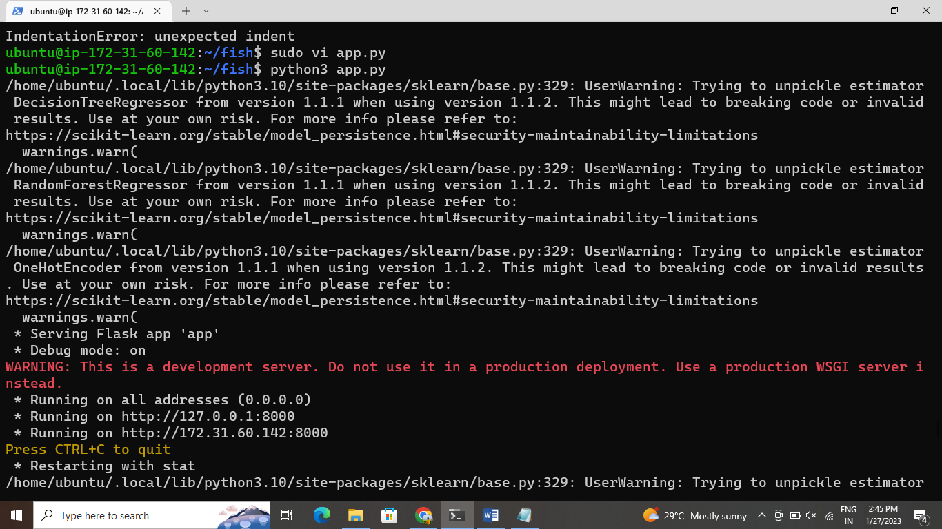

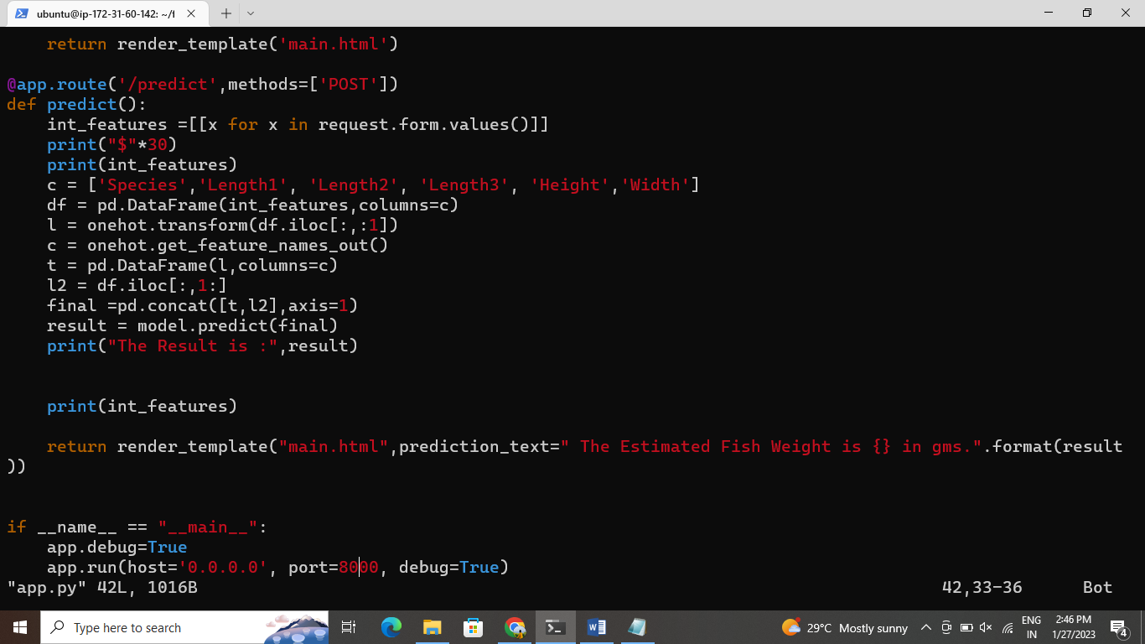

And after clone the repo and same edit app.py and copy the public ip on browser

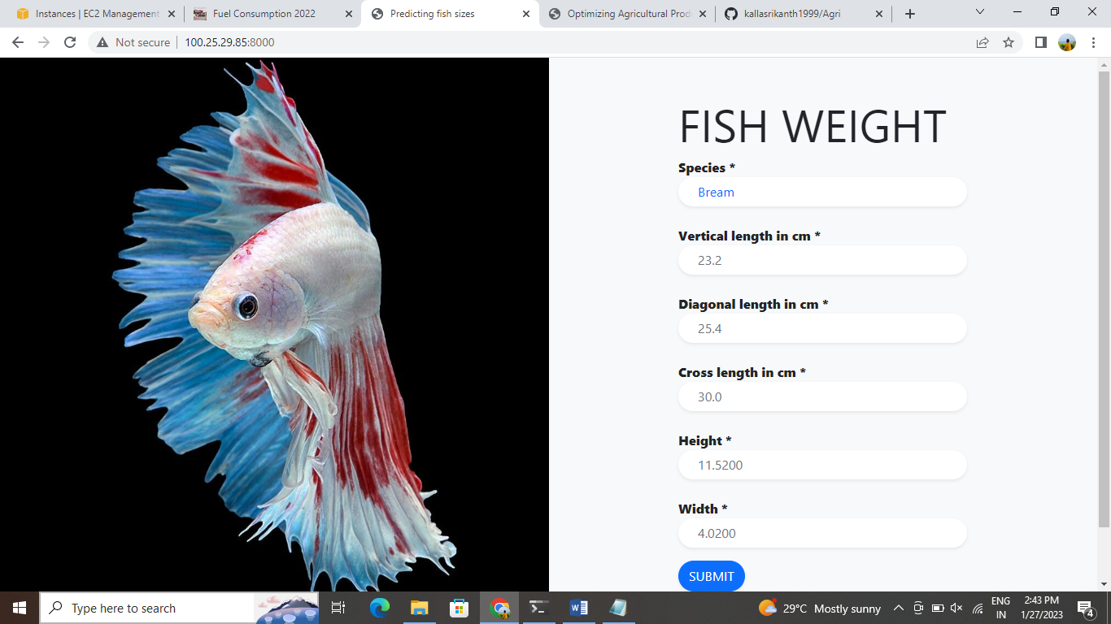

And again clone the fishrepository

Go to that directory install the requirements .txt Run the flask server

Edit the sudo vi app.py

And again run python3 app.py

Copy the public ip adress and paste it on the browser

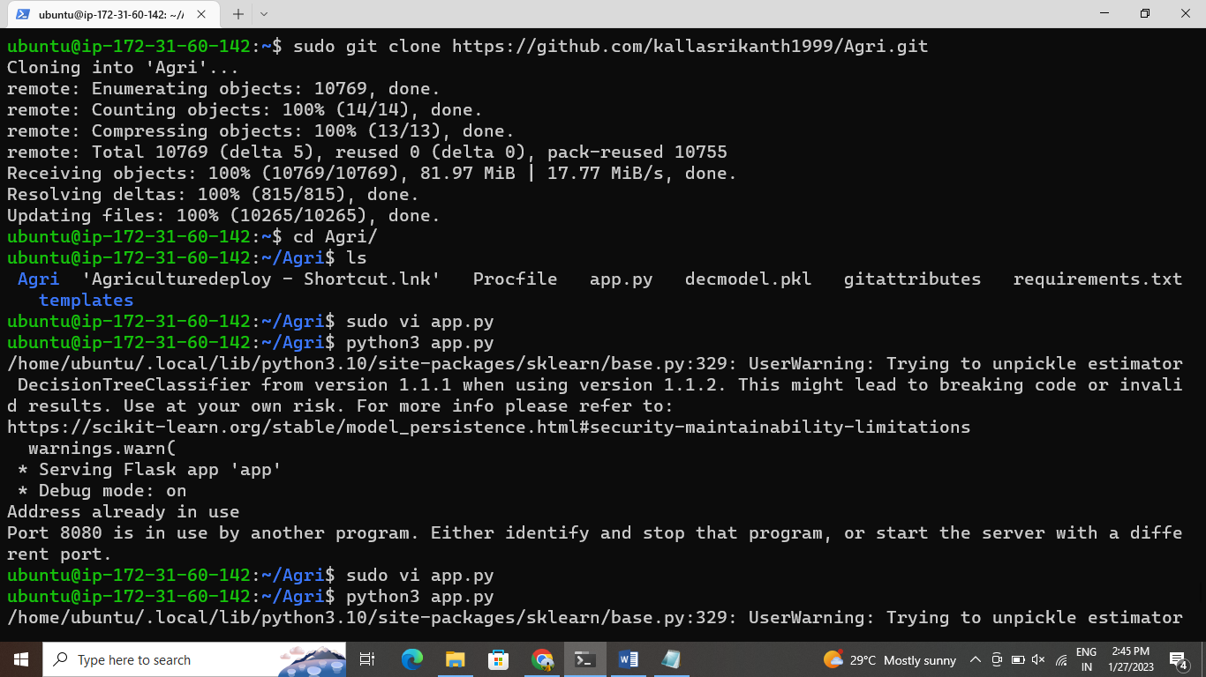

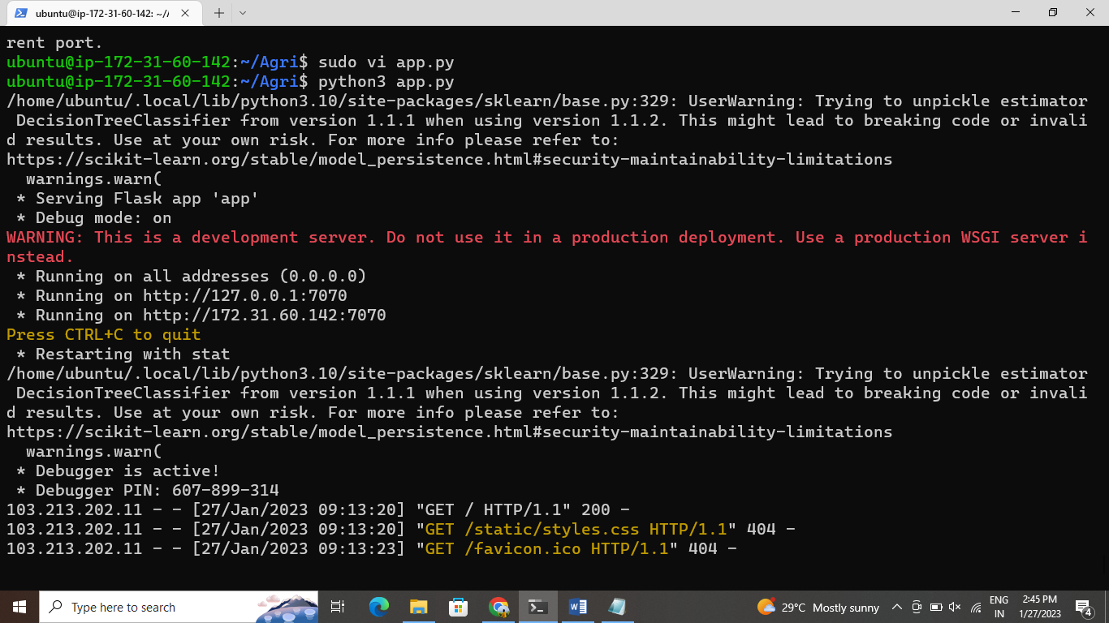

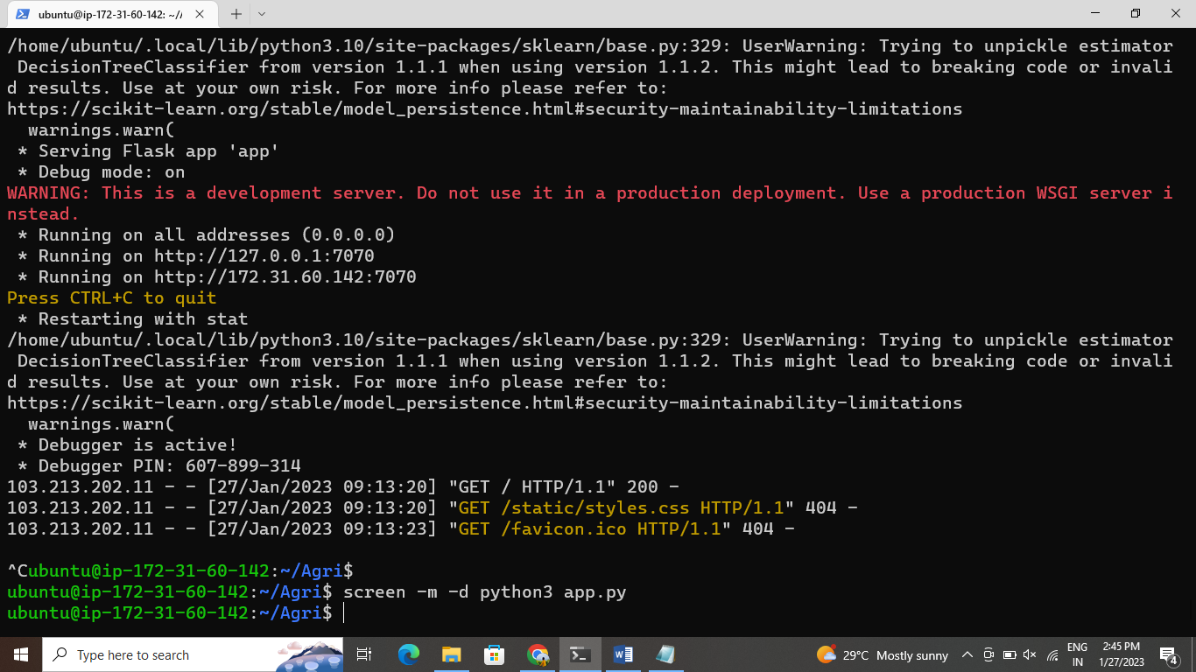

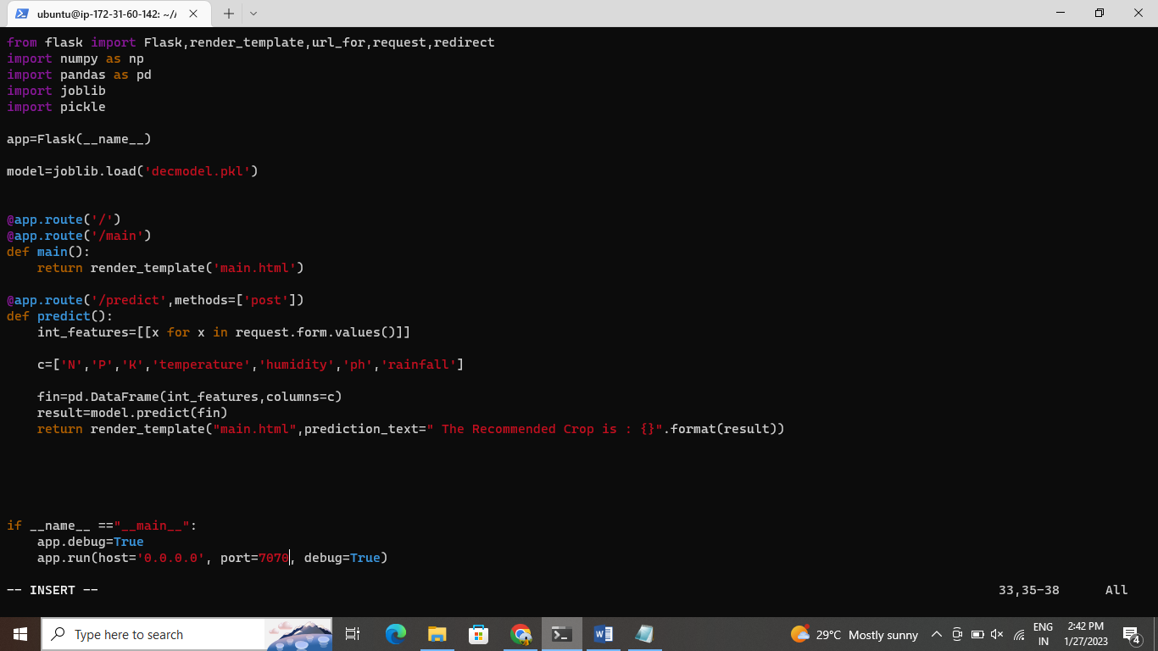

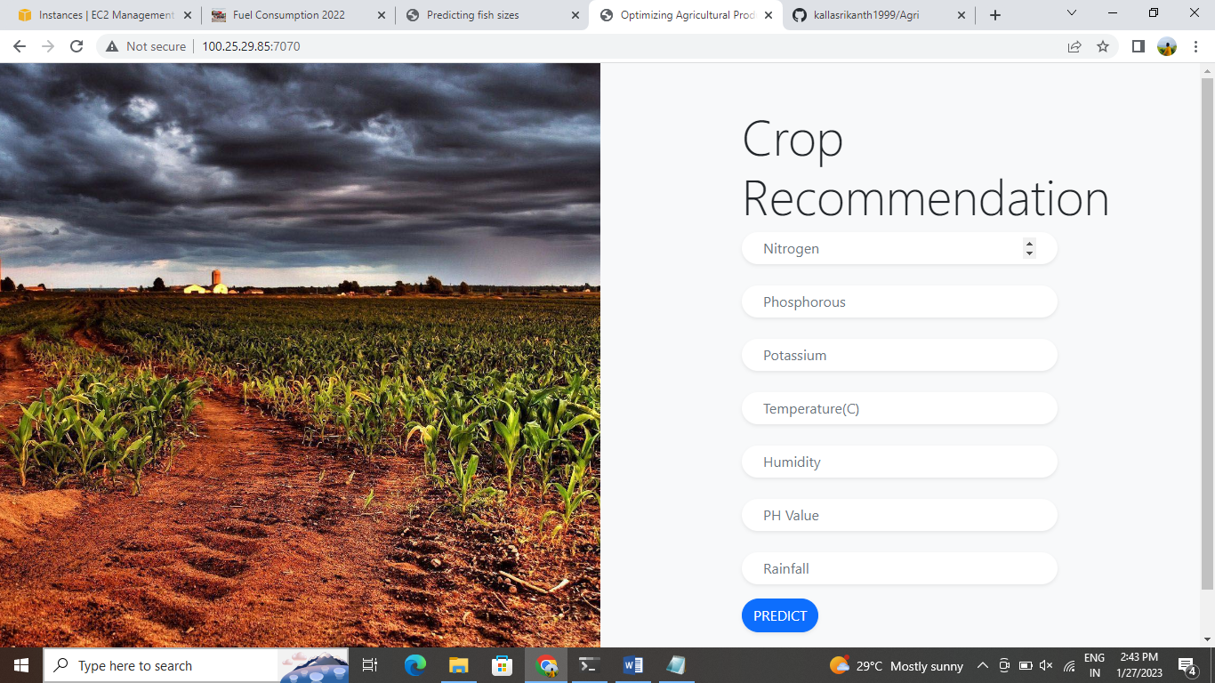

**DEPLOY FLASK/PYTHON WEB APPLICATION BY USING AUTOMATION**

JENKINS:

Jenkins is an open source automation server. It helps automate the parts of software development related to building, testing, and deploying, facilitating continuous integration and continuous delivery.

First create the ec2 instance with linux server and give the security group

Ssh-22,httpd-8080

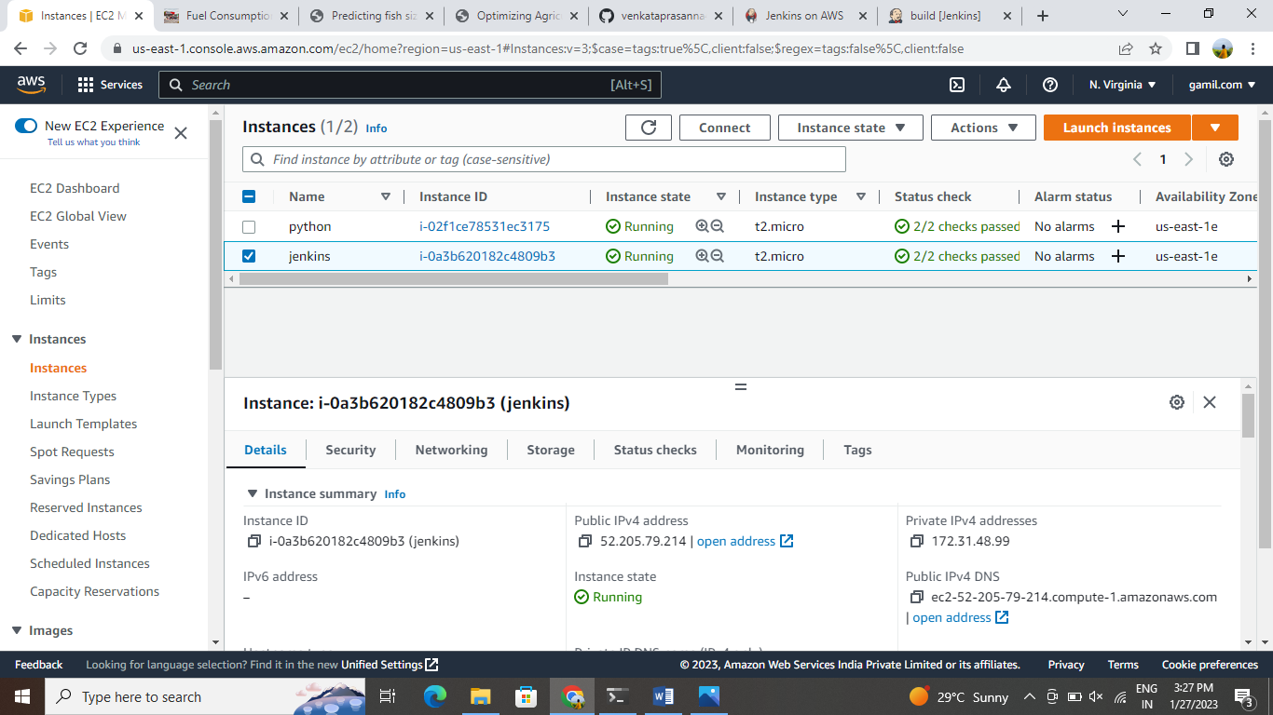

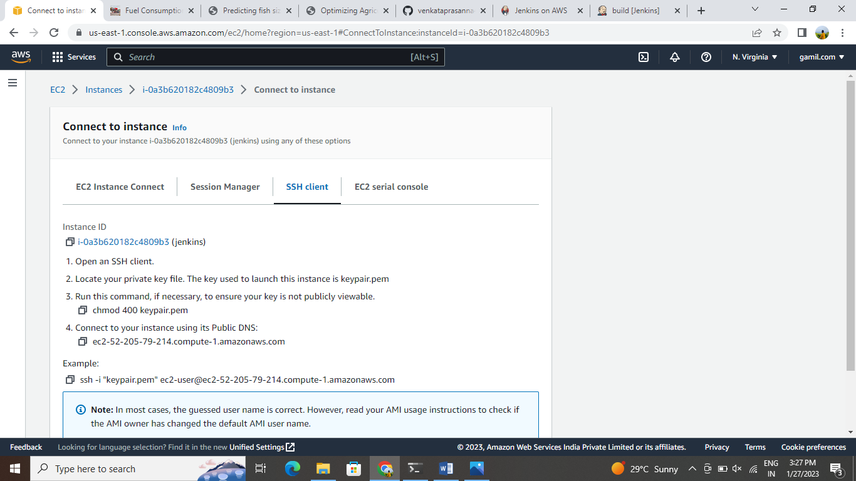

And then instance is connected to the terminal by copy the address

ssh -i ./keypair ec2-user@publicip address

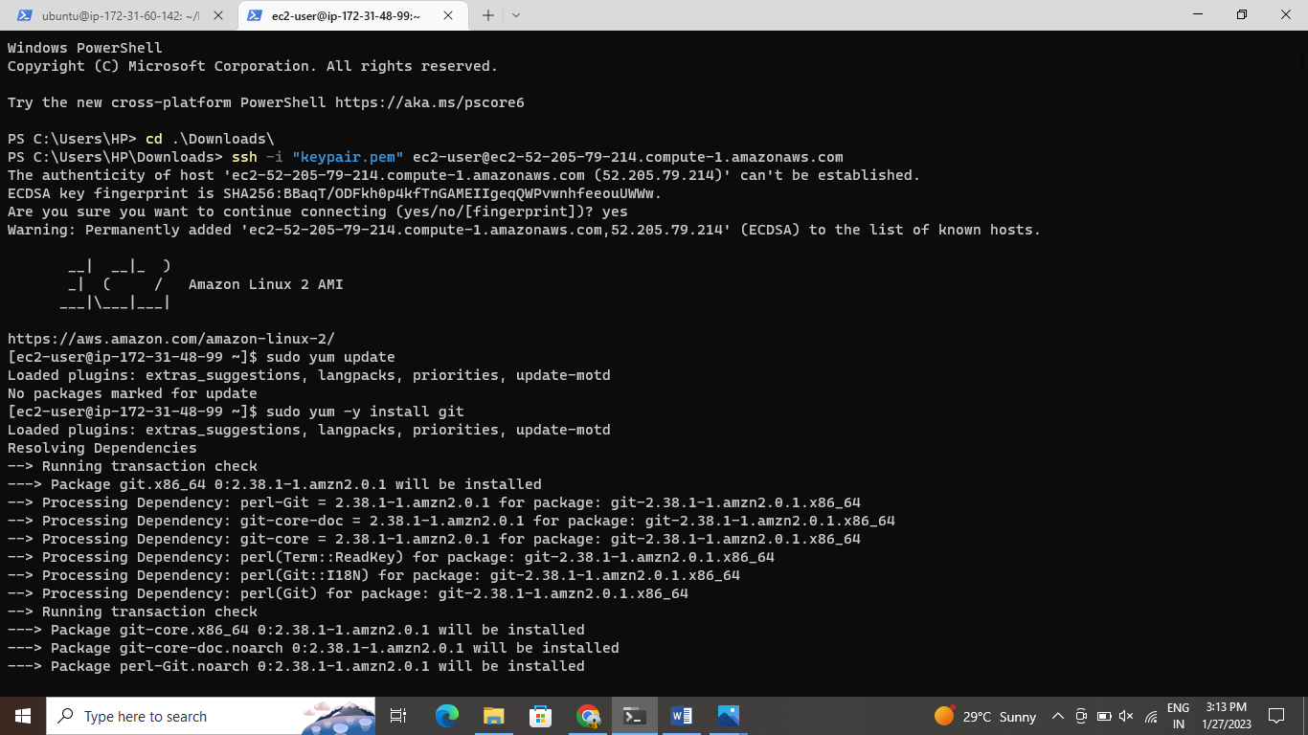

And install the java-11* in terminal by using the following command

sudo yum –y install java-11*

after install the jenkins before installing jenkins we can install the packages

sudo wget -O /etc/yum.repos.d/jenkins.repo https://pkg.jenkins.io/redhat-stable/jenkins.repo  
  
sudo rpm --import https://pkg.jenkins.io/redhat-stable/jenkins.io.key  
  
sudo yum –y install jenkins

Start the jenkins-sudo systemctl start jenkins

Sudo systemctl enable jenkins

Copy the public ip address and paste it on browser-<pubip:8080>

Give sudo cat /var/lib/jenkins/secrets/initialadminpassword

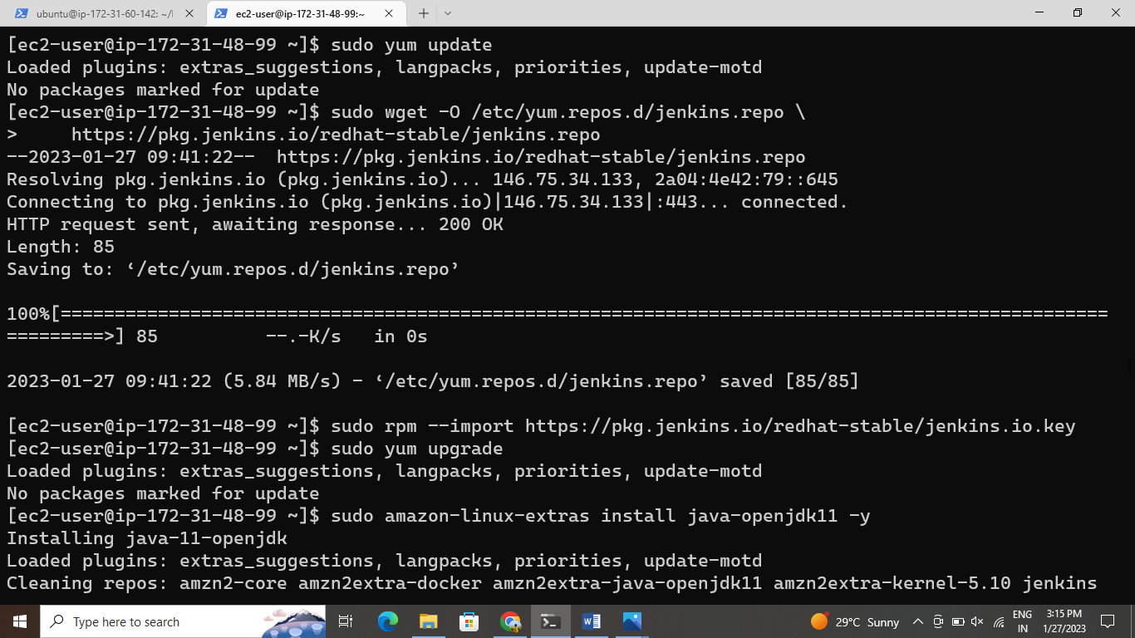

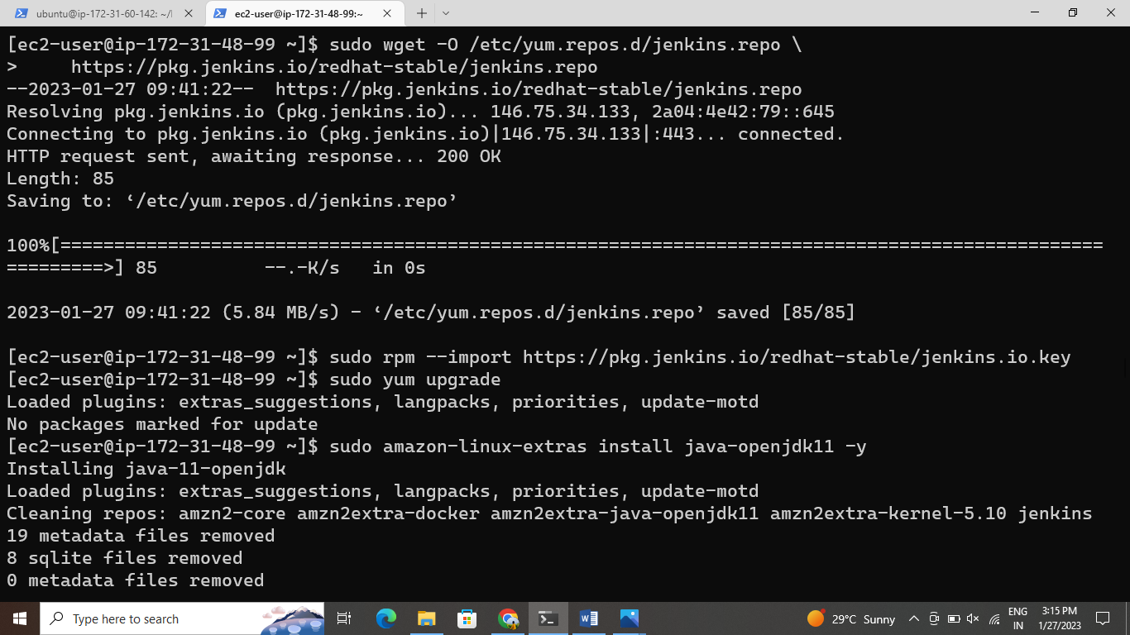

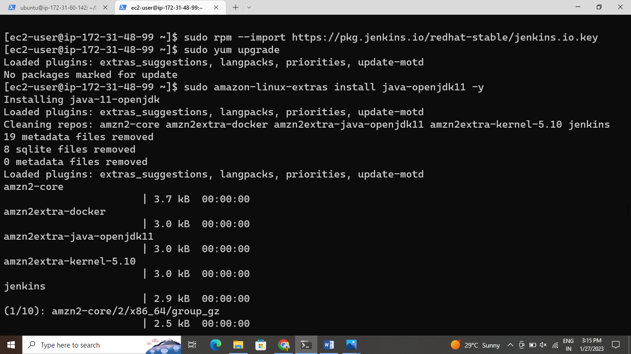

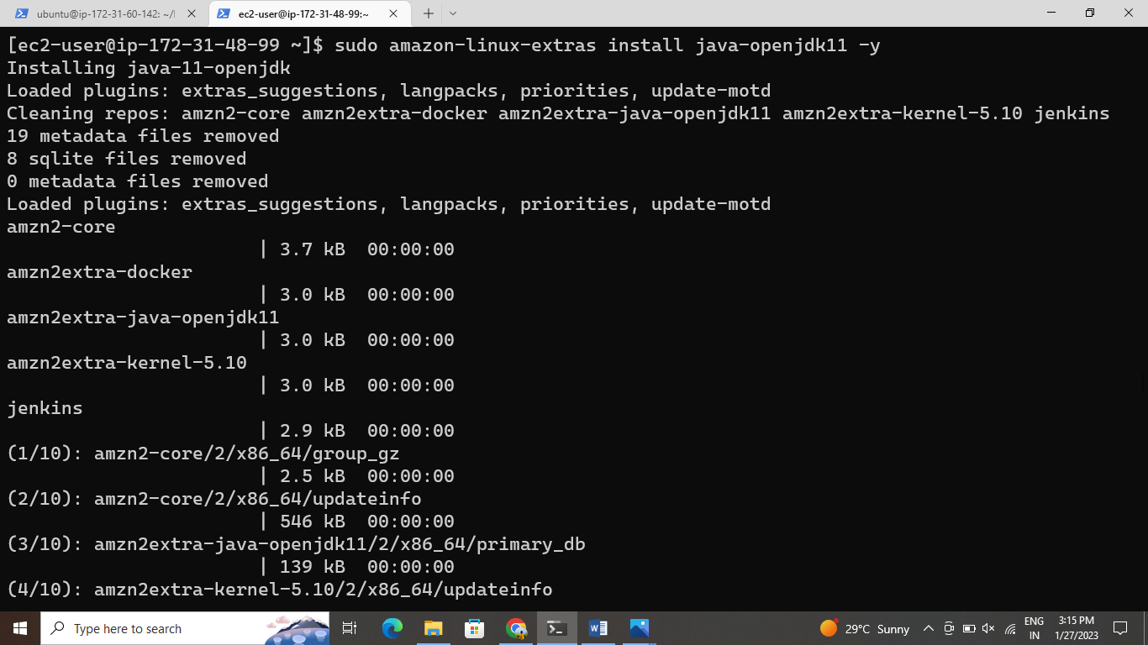

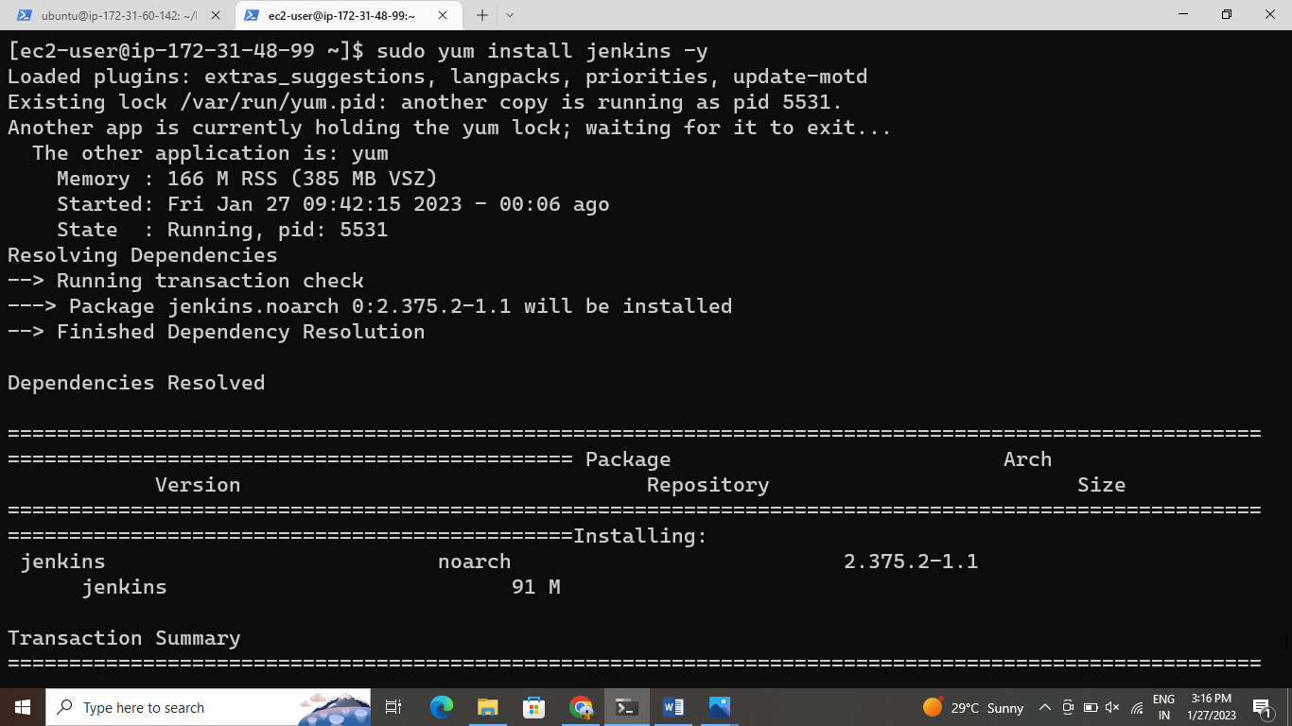

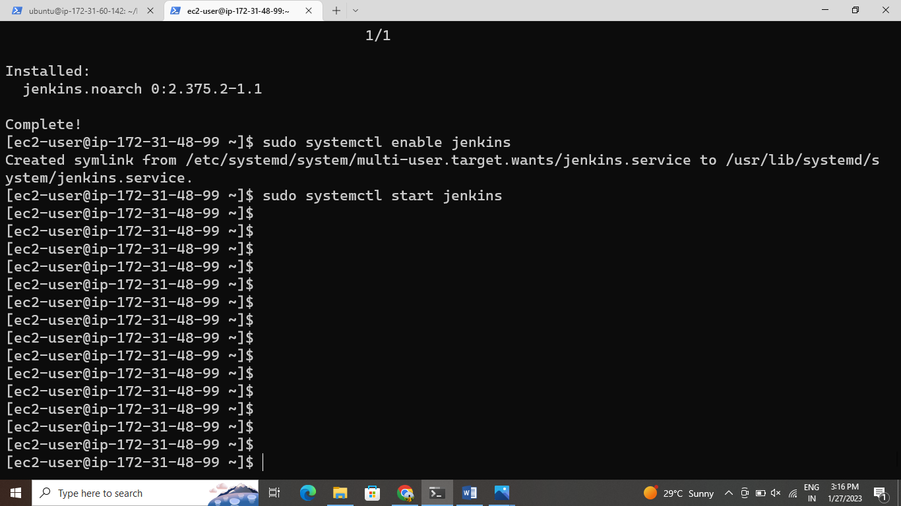

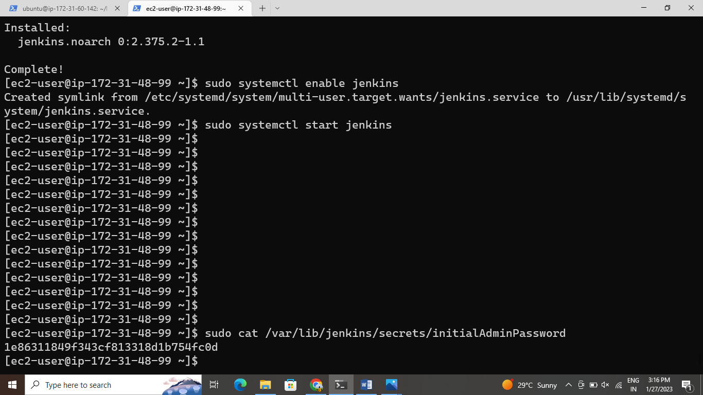

Copy the key and paste it on jenkins

And after create the first admin user

Jenkins is ready

After create a job-1 git clone the repository from github save and click on build now.

And after create a job-2 execute shell

Cd /var/lib/jenkins/workspace/job-2

Pip3 install –r requirements.txt

Python3 app.py

Save and click on build now

